H.T No
Regulations:
A15

Sreenidhi Institute of Science and Technology
(An Autonomous Institution)
Code No: 5A304 Date: 07-Feb-2025 (FN)

B.Tech II-Year I- Semester External Examination, Jan/Feb - 2025 (Supplementary)
Circuits and Networks-II (EEE)

Time: 3 Hours Max.Marks:75

Note: a) No additional answer sheets will be provided.
b) All sub-parts of a question must be answered at one place only, otherwise it will not be valued.
c) Missing data can be assumed suitably.

Bloom's Cognitive Levels of Learning (BCLL)

Remember | L1 | Apply | L3 | Evaluate | L5
Understand | L2 | Analyze | L4 | Create | L6

Part - A Max.Marks:25
Answer all QUESTIONS

 |  | BCLL | CO(s) | Marks
1 | Distinguish between Star & Delta connection of 3-ɸ system. | L3 | CO1 | [2M]
2 | Find inverse laplace transform of | L5 | CO2 | [2M]
3 | What are the necessary conditions of driving point function. | L2 | CO3 | [2M]
4 | What are the conditions of reciprocity & symmetry in terms of Z, Y & ABCD parameters. | L2 | CO4 | [2M]
5 | Define characteristic impedance & propagation constant. | L1 | CO5 | [2M]
6 | Explain frequency convolution of Fourier transform. | L2 | CO6 | [3M]
7 | Find I(s) for the following circuit. | L5 | CO | [3M]
8 | Test results for a two port network are (a) V₁=50V , I₁=2.1A, I₂=-1.1A with port 2 short-circuited (b) V₂=50V, I₂=3A, I₁=-1.1A, with port 1 short-circuited. Find Y parameters. | L5 | CO | [3M]
9 | Write short notes on T-section filters. | L1 | CO | [3M]
10 | In a balanced three phase system, the power is measured by two-wattmeter method and the ratio of two wattmeter readings is 4:1. The load is inductive. Determine the load power factor. | L3 | CO | [3M]
Part – B Max.Marks:50
ANSWER ANY FIVE QUESTIONS. EACH QUESTION CARRIES 10 MARKS.

 |  |  | BCLL | CO(s) | Marks
11. | a) | 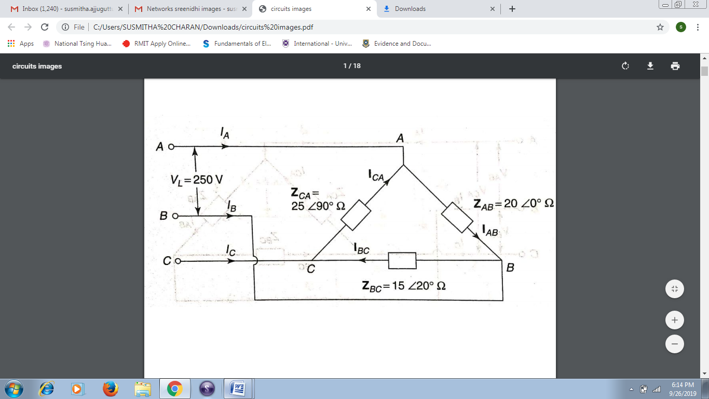  A 3-ɸ supply with a line voltage of 250V has an unbalanced delta connected load as shown in the figure1.Determine (i) Phase currents(ii) Line currents (iii)Total Active power (iv) Total Reactive power | L4 | CO1 | [5M]
 | b) | Explain how 3-ɸ reactive power can be measured using single wattmeter along with its circuit diagram & phasor diagram. | L2 | CO1 | [5M]
12. | a) | 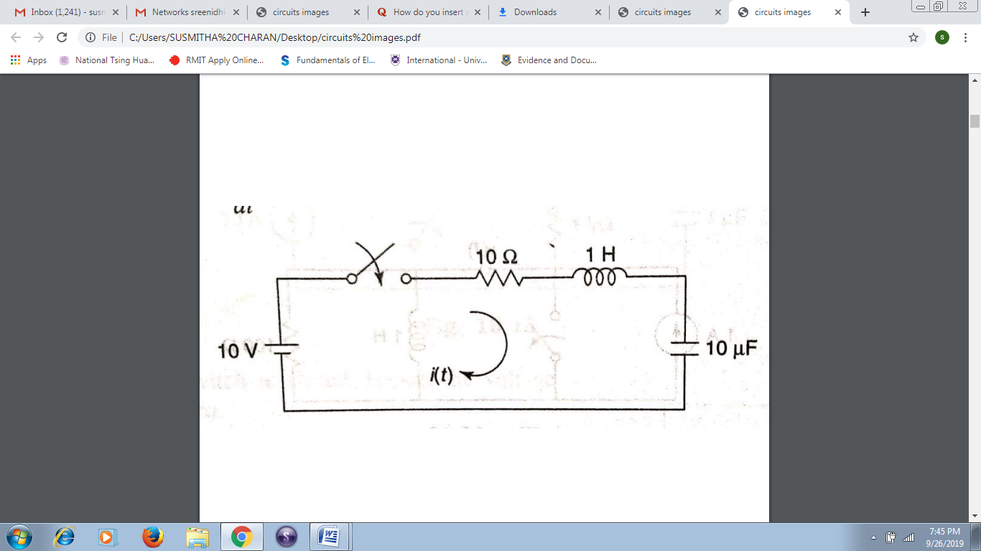  In the network shown below the switch is closed at t=0.Assume all initial conditions as zero. Find i(t), di(t)/dt, d²i(t)/dt² at t=0⁺. | L5 | CO2 | [5M]
 | b) | 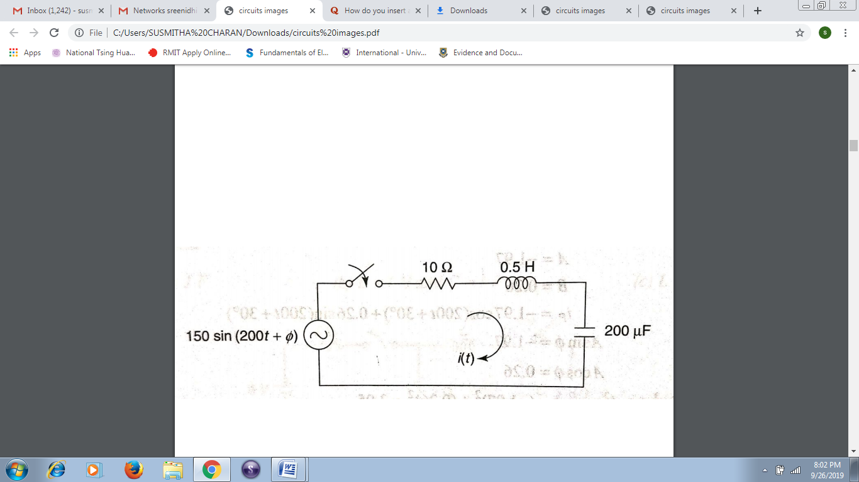  In the network shown below, determine i(t) using differential equation approach for ɸ=30⁰. | L4 | CO2 | [5M]
13. | a) | Find the driving point input impedance of the following network shown below.  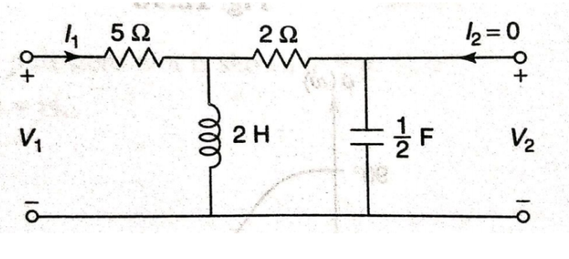 | L5 | CO3 | [5M]
 | b) | 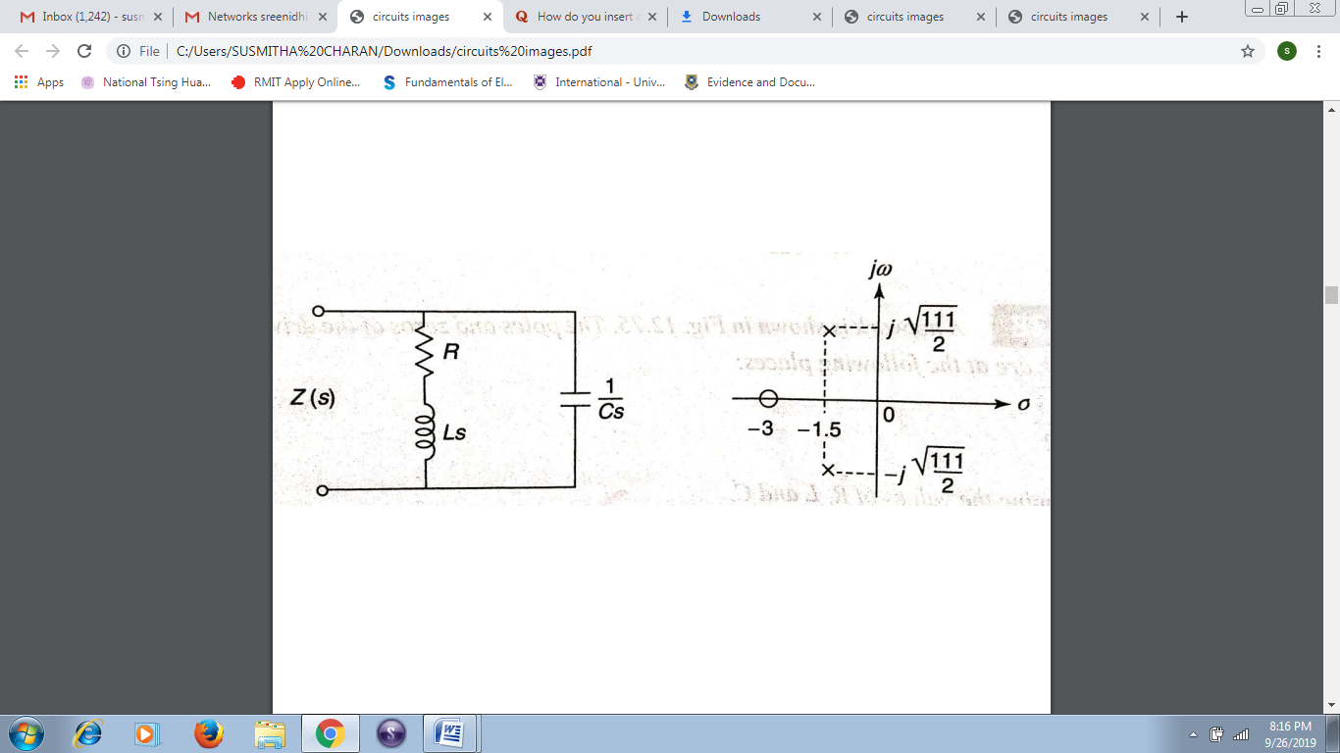  A network and its pole zero plot is shown below. Determine R, L & C IF Z(j0)=1Ω. | L3 | CO3 | [5M]
14. | a) | 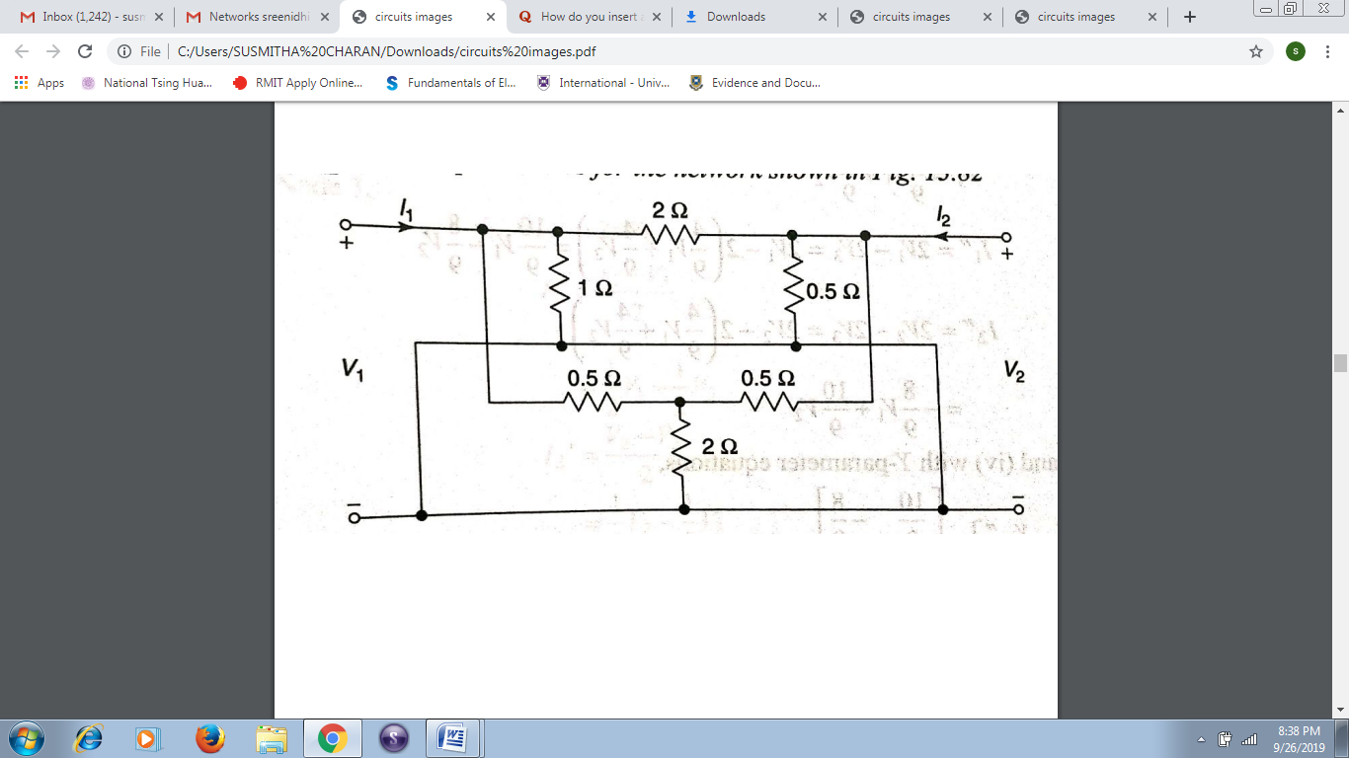  Determine Y-parameters of the network shown below. | L5 | CO4 | [5M]
 | b) | The currents I₁ & I₂ entering at Port1 & Port 2 respectively of two port network are given by I₁= 0.5V₁ – 0.2V₂, I₂= – 0.2V₁ + 0.2V₂. Find ABCD parameters. | L4 | CO4 | [5M]
15. | a) | Determine the cut-off frequency, attenuation constant & characteristic impedance of constant K-low pass filter. | L5 | CO5 | [5M]
 | b) | Design π-section m-derived high pass filter having a design impedance of 600Ω, cut off frequency of 4KHz and an infinite attenuation at 3.6 KHz. | L6 | CO5 | [5M]
16. | a) | 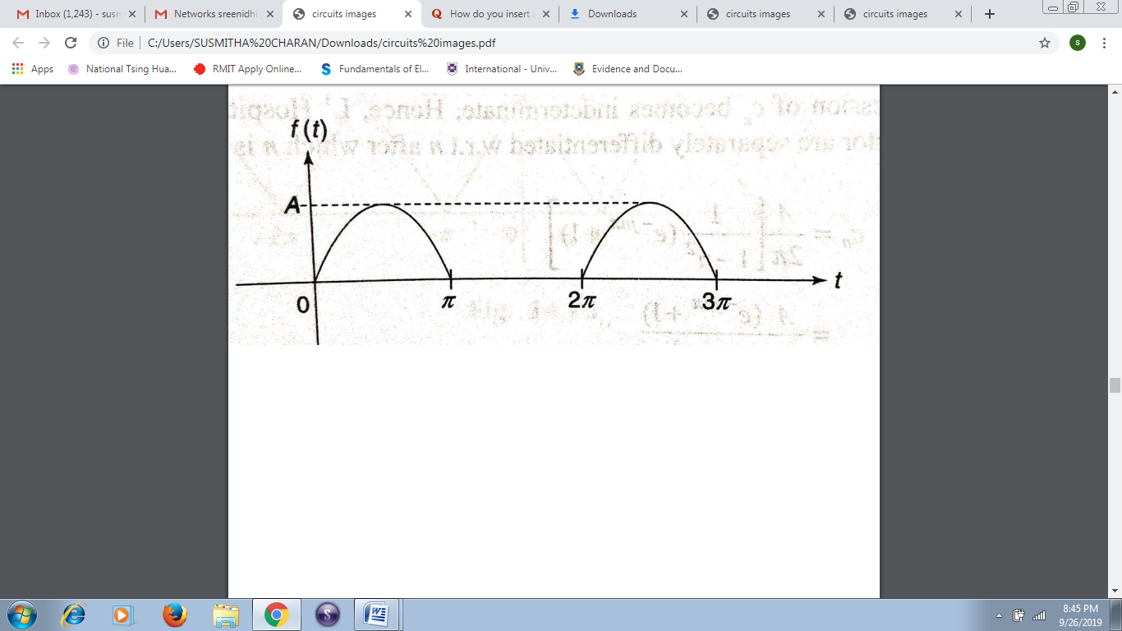  Find the exponential Fourier series of waveform shown below and draw its magnitude spectrum. | L5 | CO6 | [5M]
 | b) | Find the Fourier transform of the function below  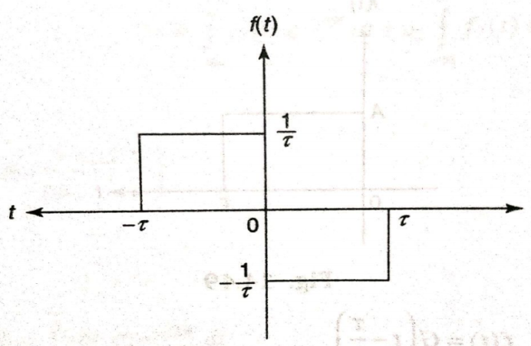 | L5 | CO6 | [5M]
17. | a) | 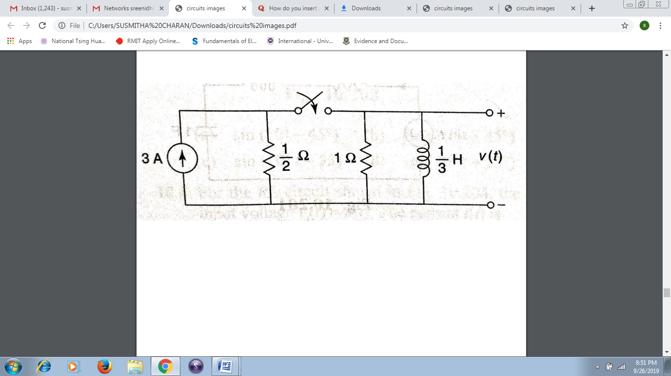  In the network shown below, the switch is closed at t=0 sec. Find v(t) for t>0. | L4 | CO1 | [5M]
 | b) | Obtain an expression for phase angle of star connected load by using two watt meter method and by using necessary phasor diagrams? | L4 | CO2 | [5M]
18. | a) | Explain odd wave & even wave symmetry of a function. | L2 | CO4 | [5M]
 | b) | 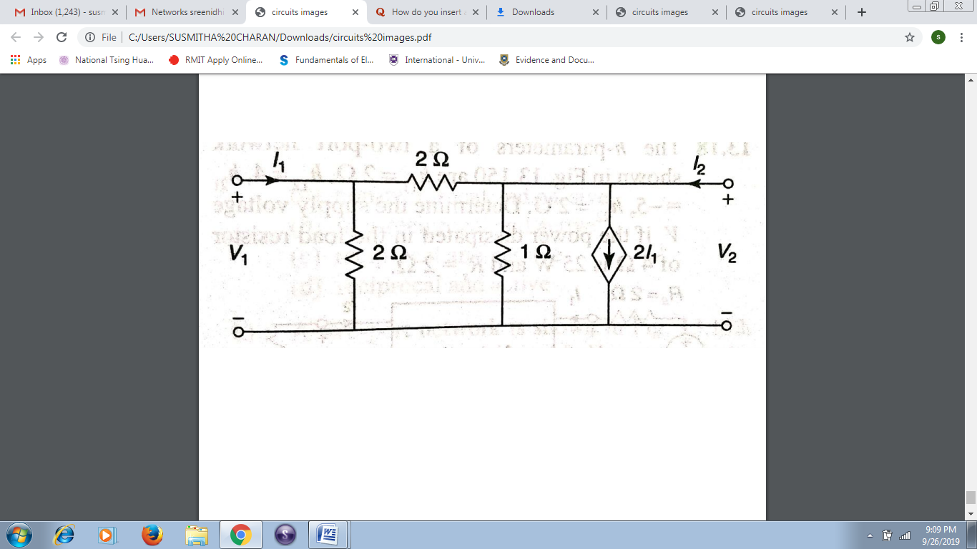  Find Z-parameters for the following network. | L5 | CO5 | [5M]

-- 00 -- 00 –

